Twitter Dream-Design

1. Description of System

Twitter provides a social networking service in which the main form of communication between users is 140 character “tweets.” Users are able to follow each other to send and receive messages, and whoever is following a given user sees their tweets when they are posted. Networks of users can be even more creative with their tweets by using hashtags (“#” with a word attached) to make any tweets in which it is contained indexed and easily searchable by followers and even users outside of that particular network (e.g. “#food”). The same can also be said for when users perform “mentions,” or tweets meant for other specific users, by typing the “@” with the other’s username attached (e.g. “@franco98765”). This is often used to direct a message that is still viewable to everyone in the network. The mention will appear in the other user’s feed as well. Of course, users can also send private direct messages to people they follow. Twitter also has an app, which helps it to be more effective in facilitating real-time communication and increasing access to a broader population, especially people in countries without widely-available desktop computers or laptops.

Compared to messaging applications like Slack, Twitter’s interface seems to be slightly more cluttered, with several different features being squeezed into small areas.

Twitter

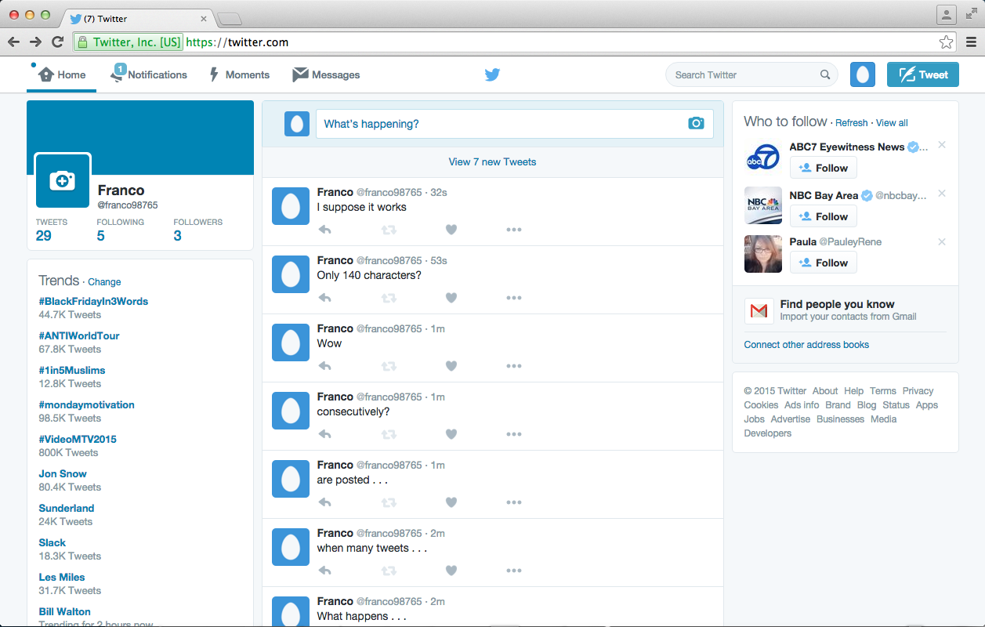

Slack

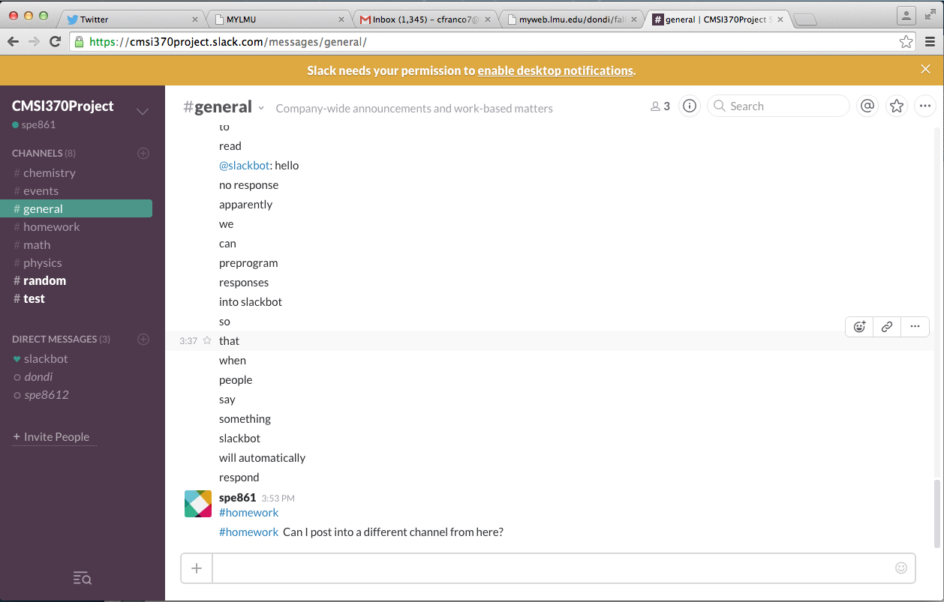

Given that this is my first time using Twitter in 1.5 years and that the last time I used it was only for a few minutes a week, it was interesting to explore and evaluate Twitter’s interface from a Learnability standpoint. For example, finding specific people to follow using the search bar was slightly difficult given that there are so many people with the same first and last name, and pressing enter after typing a name does not bring up a list. It automatically selects the first user in the drop-down list. However, there is a handy way to import your gmail contacts into twitter to instantly find people. It also took a few seconds to figure out where the *user settings* were. It turned out to be the egg icon next to the tweet button and was not the first place I thought to look.

Also, when first opening Twitter, it was slightly confusing to see random people and trends on the side menus as well as getting random tweets in the feed from people and organizations I had never contacted. This is mostly what adds to the clutter in my opinion.

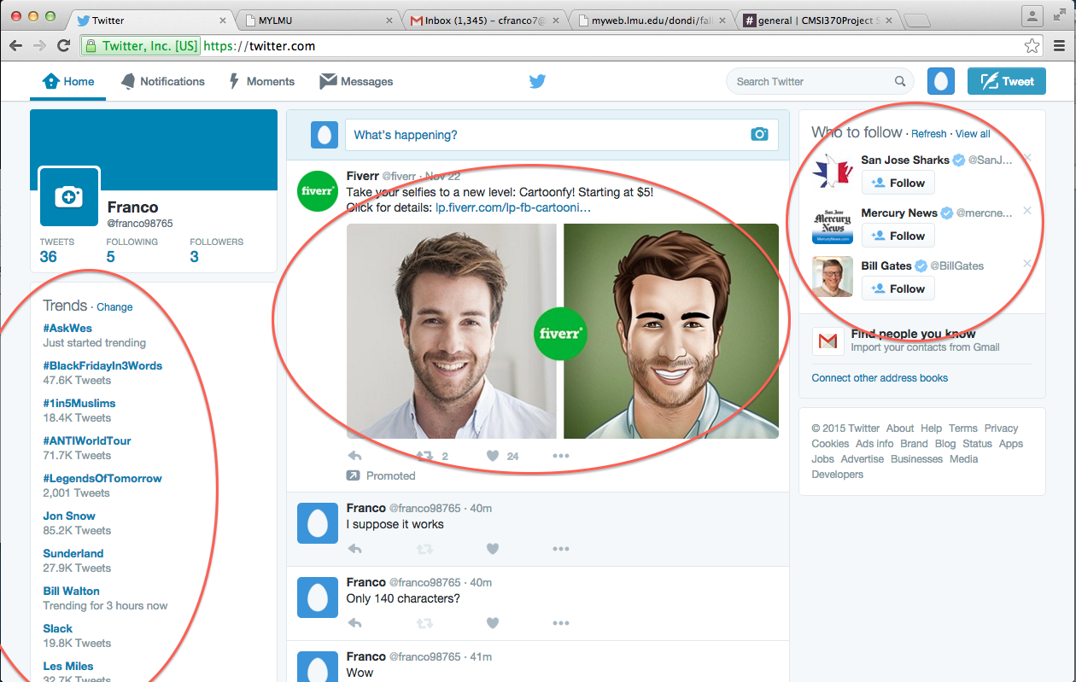

Another area for improvement is the actual display of the messags on Twitter. Although the 140 character limit may be an effective business strategy for bandwidth, creativity, efficiency, and the like, it can at times be difficult to decipher the meanings, contexts, and intentions of certain groups of messages. Often this is due to how people send messages, but there are also other times when the arrangement of the messages themselves adds time to figuring out what is being said (as opposed to in Slack, where the use of empty space allows users to quickly locate and interpret elements of the page).

Lots going on here.

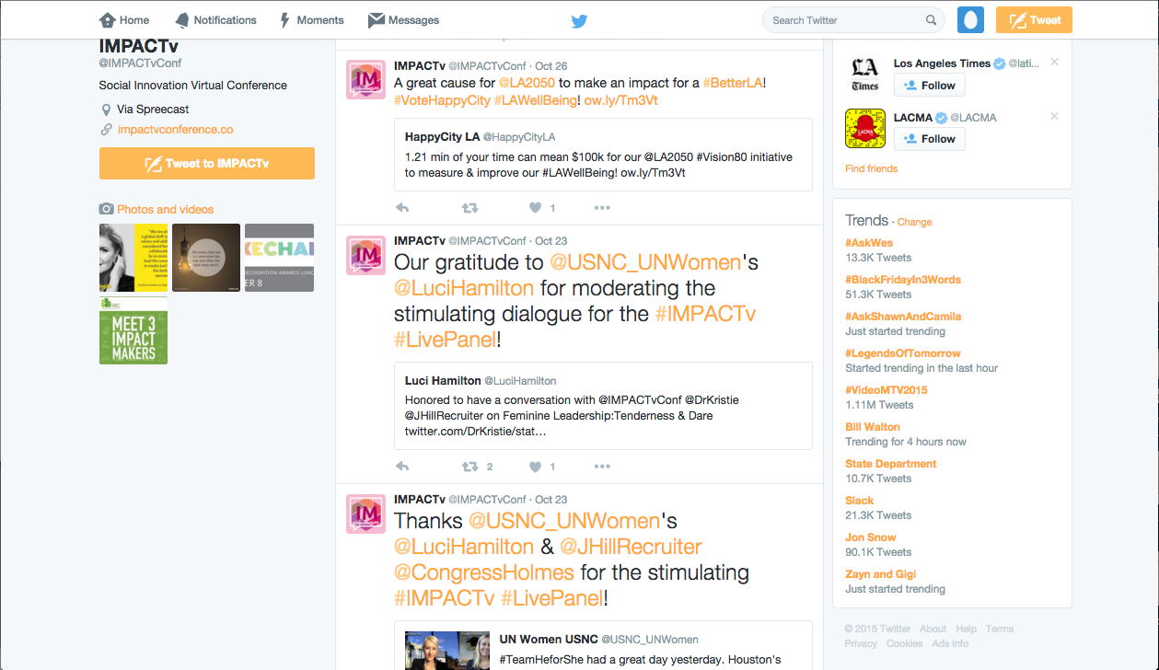

There are also some confusing aspects about replies to tweets. In the image below, the “Wow, it didn’t work” tweet refers to the “95 spaces” tweet (I tried posting a tweet with 95 spaces), yet when there are replies to the first, they extend below the original tweet and separate the two tweets from their temporal arrangement. That is, it no longer appears as though the “Wow, it didn’t work” tweet was posted immediately after the “95 spaces” tweet.

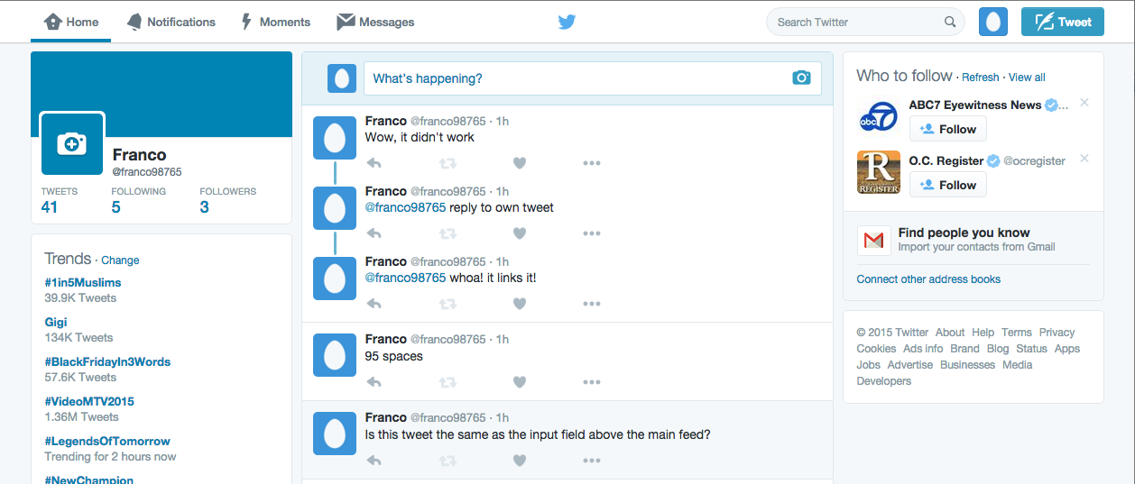

Other cases like the Followers page and Twitter’s Moments page have a mix of text and images that also make the interface pretty complex pretty quickly, thus adding more “reading time” for the user to locate specific information.

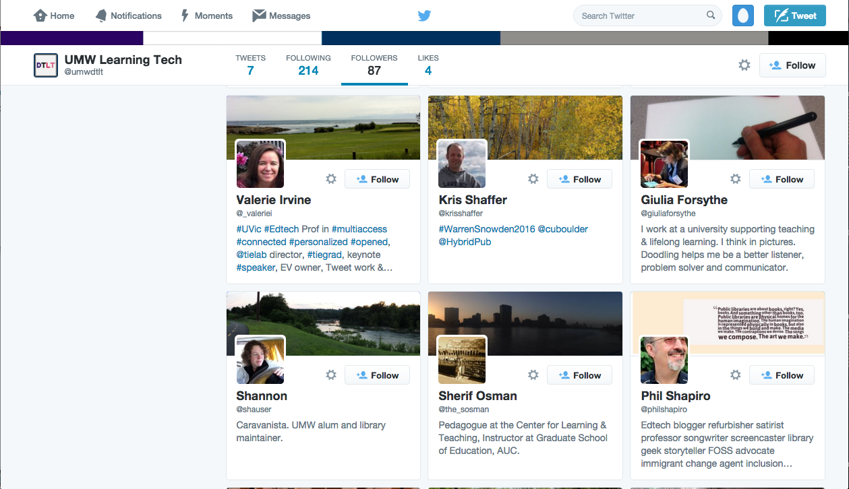

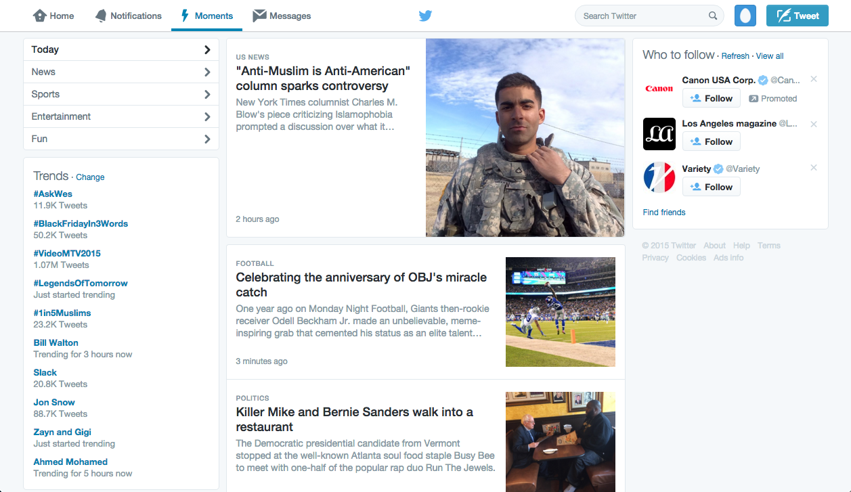

(From standstill images, this may look quite “readable,” but add a little motion and scrolling to these images and suddenly Twitter’s layout with the mix of photos and text becomes complex.)

Slack, on the other hand, utilizes empty space to keep its interface uncluttered despite a mix of images and text.

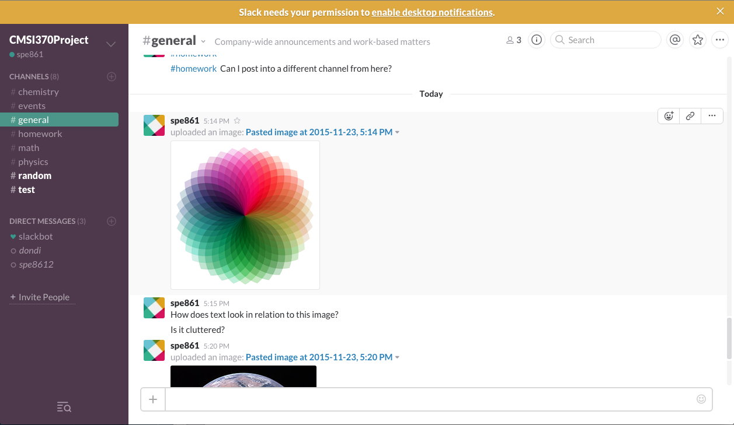

2. Top-Level Design/Layout

An alternative design may increase the “reading efficiency” of Twitter’s layout for human readers. I am proposing a new interface design that can not only accomplish this, but it can also help reveal further value in the network interactions and dynamics of Twitter data. This new interface would involve spatial animations of 2.5D “graphs,” or mappings, of hashtag and user tweets.

Users would be able to fly to twitter feeds and see them being updated in real-time. It would be analagous to a combination of RealTimeBoard and Prezi’s 2.5D interfaces and the mappings from Eigenfactor.org (an organization that maps academic citations across and between disciplines) and Cytoscape.org.

Eigenfactor’s mapping of cross-disciplinary citations in the Sciences alone

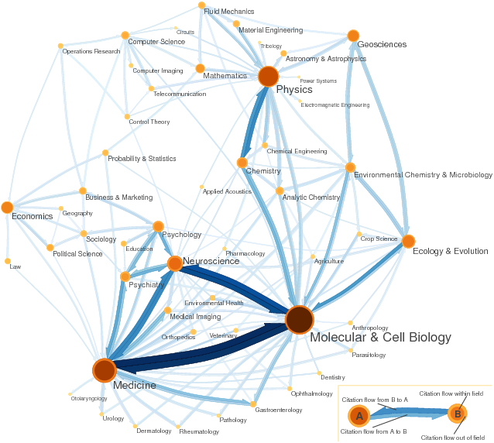

Eigenfactor’s Dynamic Map of citations between academic journals

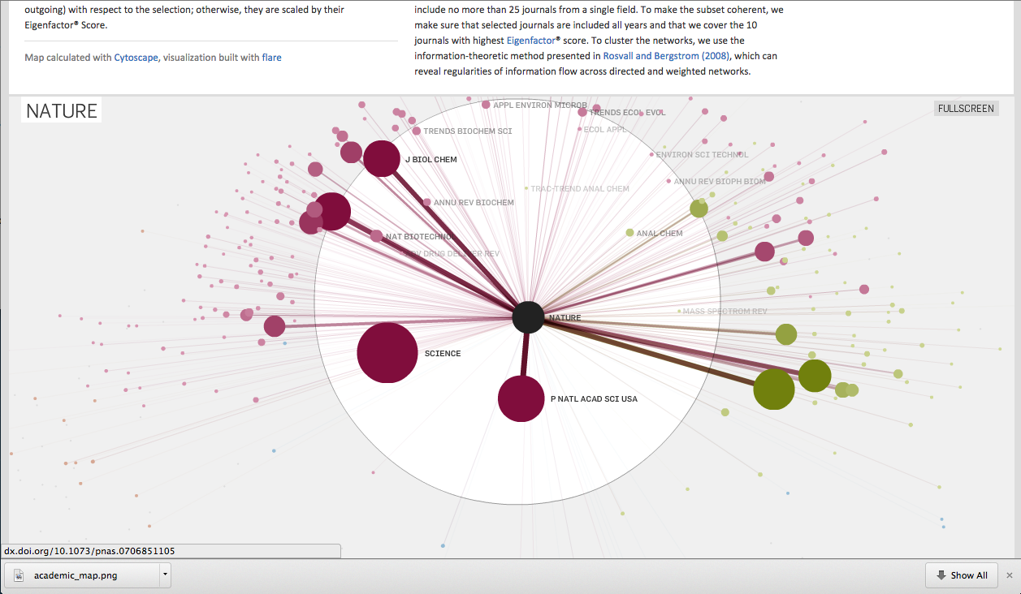

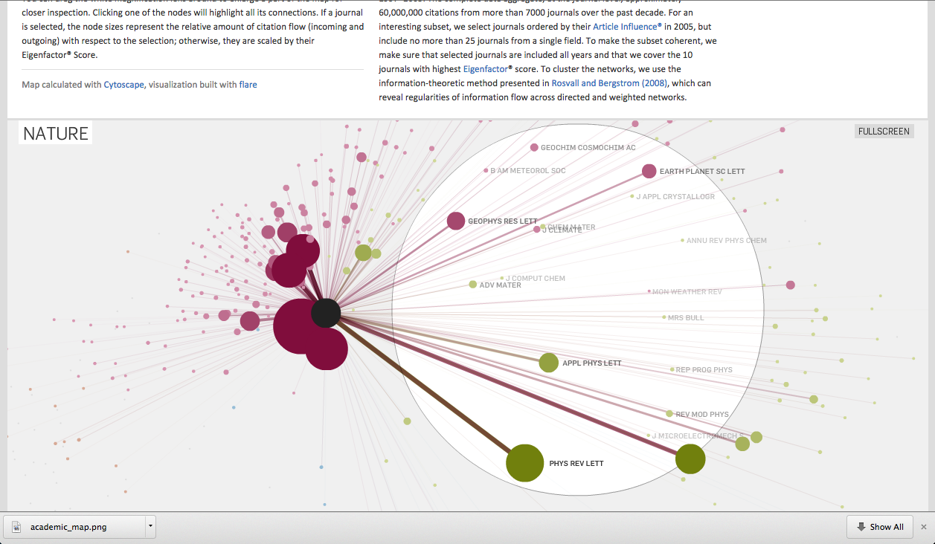

Attempt at illustrating the new Twitter interface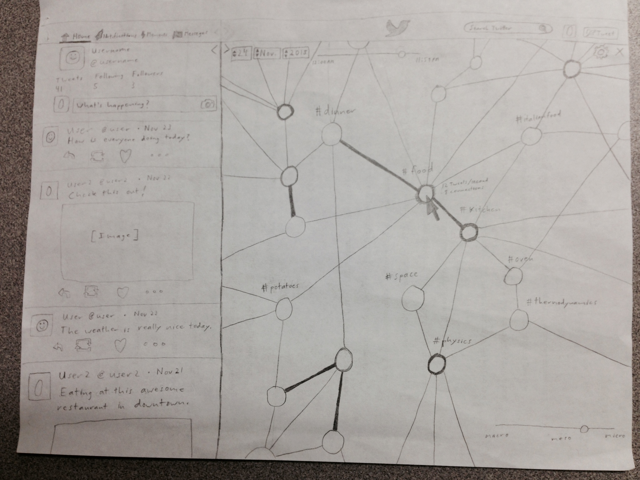

The new interface has two main displays: the tweet display on the left and the network view on the right (both of which are resizable, unlike Twitter’s original display boxes).

The tweet display incorporates what are probably the most used features of the original Twitter interface. The settings, navigation, and main feed remain the same. Only the displays to the left and right of the old main feed have been discarded. In fact, all of the previous functionalities associated with these elements remain the same in the new design.

The network display is what adds more contextual value to the service. Each node is a hashtag page/feed, and each connection between nodes represents feeds that contain tweets with shared hashtags. The deepness of a node’s border color indicates how many tweets the hashtag is receiving in short periods (frequency), and the thickness of the connection represents how often hashtags are included in the same post. Notice that nodes do not have to have deeply-colored borders to have thick connections, which are merely indicating inclusion. Using the border color to indicate frequency rather than total also has advanatages for indicating which topics are trending at the moment, or not trending. Users can see the organic development of networks deepening and fading in color as people move around to different topics and frequencies at each node change. All nodes are of equal size and do not grow or shrink in any way. This is due to the maximum count that Twitter has for tweets in a feed. It would thus be difficult to tell which feeds are the oldest otherwise because there is a point where tweets in a feed or the feeds themselves are deleted.

When the mouse pointer hovers over a node or connection, they are each highlighted to indicate they are clickable. Hovering over a node also highlights its connections, but hovering over a connection only highlights the nodes at each end. On hover, the node will also display the tweet frequency and number of connections. Connections will display the number of shared tweets.

Users can select a node to focus on, but the selected node does not necessarily have to be the center/pivot of the graph. (There is an option for that to work, however.) Once selected, the display on the left transitions to the new feed. On the graph, that particular node slightly increases in size to stand out and changes to a distinct color. Its connections also transition to that color. The other nodes at the ends of those connections do not change color, but their sizes are slightly increased to make them stand out in the network. When a connection alone is clicked, the same size-increasing and color-changing mechanisms play out for that connection and its end nodes as well as for one-level out for their child connections (but not child nodes).

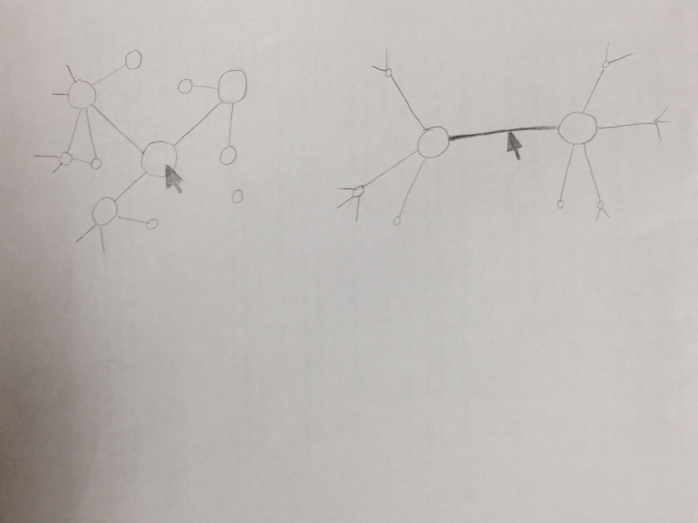

The graph/map would be constantly reshaping itself based on the dynamics and interactions of the networks, and users would be able to see this in real-time. Nodes would be appearing and disappearing based on the activity and also from Twitter deleting older feeds and tweets. The same would also be happening with the connections between the nodes. Because this interface would incorporate 2.5D software from RealtimeBoard and Prezi, users would be able to zoom in and out of different scales of the networks. (The screen would zoom to wherever the mouse pointer is.)

Macro Meso Micro

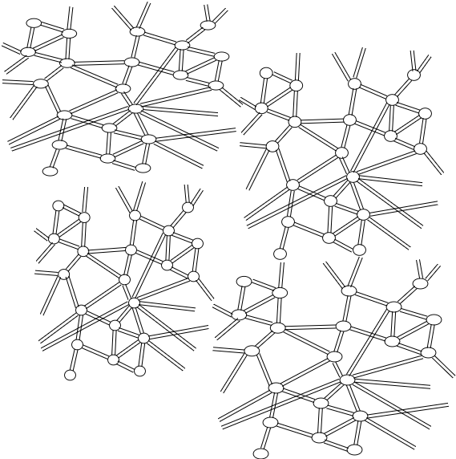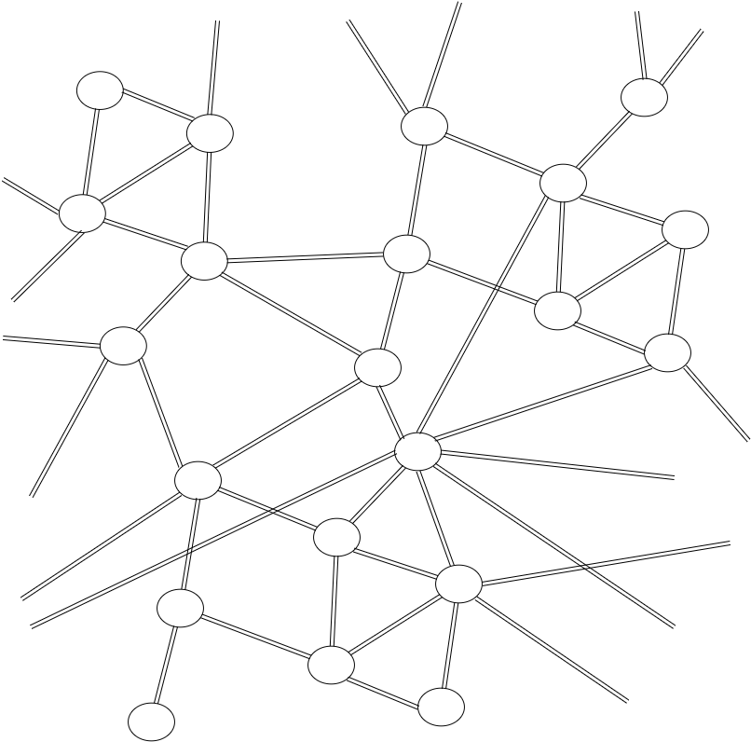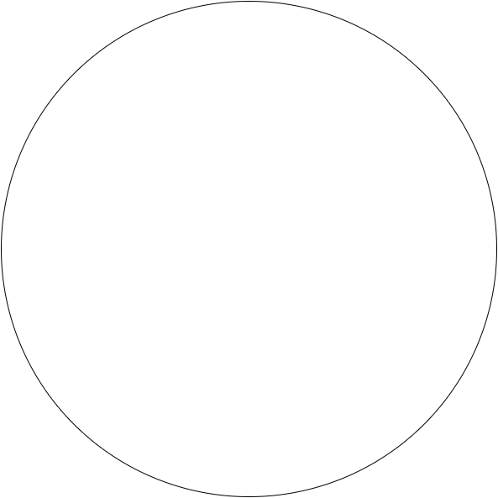

From the user’s perspective, their tweet display on the left would not change at all as they change their camera angle and zoom to fly through the network. The search bar, in addition to its previous capabilities, also allows the user to instantly fly to a node when the user searches for a hashtag or other keyword. Users will also be able to navigate by clicking in empty space and dragging the screen and/or using the arrow keys.

A filter mechanism would also be a useful feature for the graph. Users would be able to view excusively the nodes, connections, and frequencies of certain key words and hashtags. (All other elements would be dimmed, and the intended networks remain highlighted. They would even be able to have multiple filters to compare networks. There are also options on the top left of the network display for users to revert the network to past instances and potentially track how those networks developed over time. What may be extremely helpful is that if users click on nodes while viewing them in a past instance, the tweet display on the left will automatically switch to that feed and zoom to the portion of the feed corresponding to the date and time of the network display! This means that users won’t have to scroll for minutes at a time and wait for the old tweets to load if they are trying to look up a specific tweet.

Users can also choose to view a static graph such that only specific instances of the graph are displayed in a given moment, and then the graph would update every few seconds or whenever it is refreshed to show how it has been restructured. Hashtag feeds would only load into the animation when a user is within a certain zooming distance from the node (so that the system isn’t overloaded with trying to display all of Twitter all at the same time).

Users still have all of the original capabilities from Twitter’s service, just with a new way of displaying that information to more efficiently visualize the extent of certain topics and networks.

3. Usage scenarios

Suppose a natural disaster was occurring in a country with poor telecommunications infrastructure. The electricity is down. There is no wifi. The landlines are down. How would people in emergency situations contact others for help? Fortunately, smart phones are becoming a cheap and efficient means to connect digitally to the rest of the world, and research has shown that out of all the technology that people in developing countries cannot afford, smartphones are turning out to be a cost-effective and empowering option. They also happen to use satellites to transmit and receive data. Twitter’s app has already proven to be an effective instrument in connecting missing people to their loved ones and providing aid to specific areas in a distaster. What if humanitarian aid workers could get a better sense of which areas were in the most dire need? They could use the filters to search key words or hashtags, and the graph would highlight the nodes, connections, and frequency of tweets for those terms. Instead of having to sort through pages of tiny font and ill-formatted text and images, humanitarian organizations would be viewing a graph that automically reveals the concentrations of certain feeds and how they change in real-time.

Another example of how this interface might be helpful is for research. Suppose a researcher wanted to see how the Arab Spring was related to other social movements occurring at the same time in a different part of the world. The researcher would be able to search keywords related to a few of the movements being investigated and see their corresponding color-coded networks. This would be valuable for seeing where those networks converged and diverged. Using the time slider, the researcher would be able to see when certain trends appeared in the networks and track the development of the connections over time. They would even be able to pull up the specific tweets related to those past instances! (as made possible by clicking on a node while viewing the network as a past instance)

4. Rationale

Adding the network display to the Twitter interface allows the service to provide a broader set of valuable information to users by having more indicators, or means of indicating, at its disposal. For example, this new interface eliminates the tedious clutter of random trends and random people on the side columns of the original interface and instead allows users to simply see which trends simultaneously in the structure of the networks themselves. No more scrolling or clicking through pages and pages of feeds to see how everything connects. The graph already *shows* how everything connects.

More importantly, this interface provides a lot of immediate opportunity to add more functionality to the services as a whole. The example we have already explored is how the time settings in the network display can also help users easily navigate in the tweet display. The standard Twitter functionalities have an increased capacity garnered from the network display. The idea of having displays augment one another opens up gives Twitter an added flexibility to build services on its existing API. In this it is the combination of communication and structure that is adding value.

5. Usability Metrics

*Learnability*

For new Twitter users, the hope is that this interface is more intuitive since it features much more direct manipulation. The network view requires users to manipulate the camera and also access information by clicking directly on objects. In a way, it condenses what we considered to be excess display features into *structure* such that what previously required lots of reading and clicking now only requires observation. The structure, color-coding, and dynamics of the network reveal the same information as the original “trends” display but with much less effort required by the user.

*Efficiency*

For experienced Twitter users, keeping the most used portions of the standard Twitter interface would be beneficial according to usability design principles since it maintains icons, proportions, and layouts that they are already familiar with. Performing the same actions should not be too difficult. The new network display has features that augment the original functionalities of the tweet display elements. Plus, if users do find the network display to be distracting or to be a learning curve, they can simply hide it.

*Memorability*

For experienced users, this interface would be highly memorable, especially since the tweet display is taken directly from the original Twitter interface. The inuitive features of the network display would also add to the memorability since it is “visual display of information” to begin with.

*Errors*

Unfortunately, with direct manipulation may come a larger probability for errors. Experienced users may at times confuse the network display settings for being able to affect the tweet display and accidentally click on the gear icon expecting to find options for tweeting.

*Satisfaction*

This obviously depends on what Twitter is being used for. New users may be indifferent to what the network display has to offer since they are just beginning to explore the dynamics of Twitter’s services. Experienced and unconventional users may find it extremely valuable due to the extra context that the networks provide.

In short, the strongest metrics for this interface would probably be Learnability, Efficiency, and Memorability, and the lowest performing metrics would probably be Errors and Satisfaction (satisfaction not being a strong point since it is so subjective and can go in either direction).

Credits & References

Twitter Display Requirements

<https://about.twitter.com/company/display-requirements>

Eigenfactor.org

<http://eigenfactor.org/>

Prezi

<https://prezi.com/>

RealtimeBoard

<https://realtimeboard.com/app/dashboard/>